Table of Contents

**Sets of Books - Change Reporting dates - Cannot Update - Unicode errors** 1

***Default unicode setting in osf.ini file =" nounicode=true "*** 1

***Unicode - Error - Refresh failed. Found 0 records*** 1

***Bing response to Error Refresh failed. Found 0 records*** 2

***Greek example Screenshots*** 3

***RTL (Right-to-Left languages)*** 4

***Th-Thai*** 4

***LTR (Left-to-Right languages)*** 4

***Turkey*** 4

***Estonian*** 5

**Change the default setting " nounicode=true " in osf.ini file** 5

**Sets of Books - Change Reporting dates - Cannot Update - Unicode errors**

These sets of Books are downloaded via the Download option on Let osFinancials help you to create a Set of Books? From the osFinancials databases.

Updating all Sets of Books financial years is successful except the French and languages listed below.

***Default unicode setting in osf.ini file =" nounicode=true "***

***Unicode - Error - Refresh failed. Found 0 records***

Cannot set reporting dates in **Setup → Reporting dates** - produces errors when default setting in the osf.ini files is set to

*nounicode=true*

Before in earlier versions in 2022 this error was replicated since the nounicode setting was implemented in osFinancials5.1.0.49

*Unicode - Error - arithmetic exception, numeric overflow, or string truncation*

In osFinancials5.1.0.100 the error is replicated.

*Refresh failed. Found 0 records*

***Croation***

HR-BOSNIA

HR-CROATIAN-CONTOH_INA

HR-CROATIAN-PERSONID

HR-MONTENEGRO

***Greek***

EL-CYPRUS

EL-GREECE

***Estonian***

ET-ESTONIAN-2X

ET-ESTONIAN-3X

***French***

FR-BENIN

FR-BOOKS

FR-BURKINAFASO

FR-CAMEROUN

FR-CENTRAFRICAINEREPUBLIQUE

FR-COMORES

FR-FRANCE

FR-GABON

FR-GUINEE

FR-HAITI

FR-MALI

FR-MAURICE

FR-NIGER

FR-REPCONGO

FR-RWANDA

FR-SENEGAL

FR-TCHAD

FR-VANUATU

***Lithuanian***

LT-LITHUANIA

***Bing response to Error Refresh failed. Found 0 records***

"*I’m sorry to hear that you’re encountering an error. The error message you provided is related to Firebird databases. The error message “Refresh failed. Found 0 records” is a common error message that can occur when the query returns no records. This error message is not specific to any particular database or programming language.*"

[forums.devart.com -](https://forums.devart.com/viewtopic.php?t=39146)

[forums.devart.com](https://forums.devart.com/viewtopic.php?t=36214) -

***Greek example Screenshots***

After downloading and opening the set of Books, e.g. EL-GREECE, in the **Setup → Reporting dates** screen the Greek language (e,g, Months) is not displayed correctly.

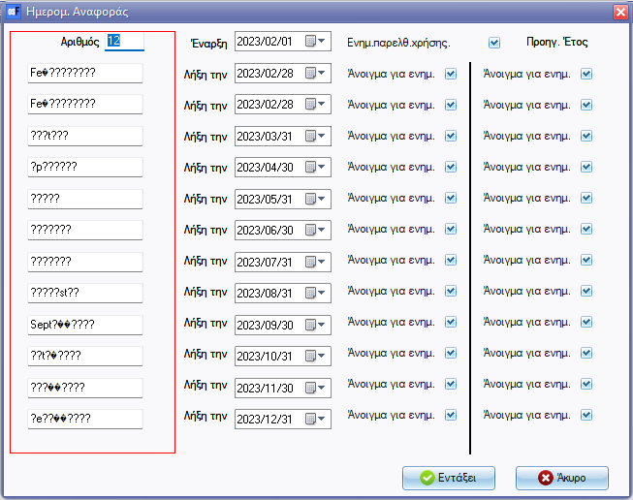

After changing the Start date, the Months is displayed correctly, when click OK button on the " *Refresh failed. Found 0 records* " error message.

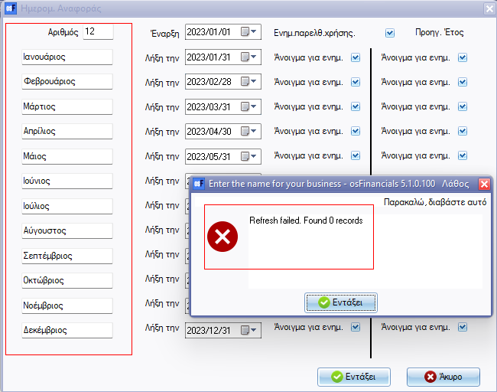

**Sets of Books - Not available as a download in osFinancials5.1.0.100**

Not available on the download option on "[**Let osFinancials help you to create a Set of Books**](hnd-topic://fad498d203d144d882325cf1c2f7c48f)". See a list of the [Sets of Books available for a download](hnd-topic://6cc2d09a4da849a8ad7c95954b4ba2e6).

These Sets of Books produced the similar error in osFinancials5.1.0.49

*Refresh failed. Found 0 records*

***RTL (Right-to-Left languages)***

***Th-Thai***

TH-THAILAND

***LTR (Left-to-Right languages)***

***Turkey***

TR-TURKEY

***Estonian***

ET-ESTONIAN-2X

ET-ESTONIAN-3X

**Change the default setting " nounicode=true " in osf.ini file**

" ;nounicode=true " or set to " nounicode=false "

if nounicode=true is commented = to " ;nounicode=true " or set to " nounicode=false " it replicates this error in Firebird databases

*unknown ISC error 0*

It changes the error from " *Refresh failed. Found 0 records* " to " *unknown ISC error 0* "

**Bing response**

*"I’m sorry to hear that you’re encountering an error. The error message you provided is related to Delphi XE TClientDataSet.Next function. It is a known issue that can occur when using data pagination over a ClientDataSet, DataSetProvider, and SQLQuery combination 1. The error is intermittently raised and could mean a connection issue, but the database is stored locally.*

*One possible solution is to set FetchOnDemand = False 1. However, this may not be a viable solution if you have a large dataset 1. Another solution is to fetch the records at first and paginate over them already in-memory."*

See

* [stackoverflow.com](https://stackoverflow.com/questions/30305555/unknown-isc-error-0-on-delphi-xe-tclientdataset-next)
* [forums.devart.com](https://forums.devart.com/viewtopic.php?t=23749)